UNITED STATES

SECURITIES AND EXCHANGE COMMISSION
WASHINGTON, D.C. 20549

FORM 8-K

CURRENT REPORT

Pursuant to Section 13 or 15(d)
of the Securities Exchange Act of 1934

Date of Report (Date of earliest event reported): December 19, 2025

Clearside Biomedical, Inc.

(Exact name of Registrant as Specified in Its Charter)

Delaware

001-37783

45-2437375

(State or Other Jurisdiction
of Incorporation)

(Commission
File Number)

(IRS Employer
Identification No.)

900 North Point Parkway

Suite 200

Alpharetta, Georgia

30005

(Address of Principal Executive Offices)

(Zip Code)

Registrant’s Telephone Number, Including Area Code: (678) 270-3631

(Former Name or Former Address, if Changed Since Last Report)

Check the appropriate box below if the Form 8-K filing is intended to simultaneously satisfy the filing obligation of the registrant under any of the following provisions:

- Written communications pursuant to Rule 425 under the Securities Act (17 CFR 230.425)

- Soliciting material pursuant to Rule 14a-12 under the Exchange Act (17 CFR 240.14a-12)

- Pre-commencement communications pursuant to Rule 14d-2(b) under the Exchange Act (17 CFR 240.14d-2(b))

- Pre-commencement communications pursuant to Rule 13e-4(c) under the Exchange Act (17 CFR 240.13e-4(c))

Securities registered pursuant to Section 12(b) of the Act:

Title of each class |  | Trading |  | Name of each exchange
 |  | Symbol(s) |  | on which registered
Common Stock, par value $0.001 per share |  | CLSD |  | The Nasdaq Stock Market LLC

Indicate by check mark whether the registrant is an emerging growth company as defined in Rule 405 of the Securities Act of 1933 (§ 230.405 of this chapter) or Rule 12b-2 of the Securities Exchange Act of 1934 (§ 240.12b-2 of this chapter).

Emerging growth company ☐

If an emerging growth company, indicate by check mark if the registrant has elected not to use the extended transition period for complying with any new or revised financial accounting standards provided pursuant to Section 13(a) of the Exchange Act. ☐

Item 1.03. Bankruptcy or Receivership.

Voluntary Petition for Bankruptcy

As previously disclosed in Clearside Biomedical, Inc.’s (the “Company”) Current Report on Form 8-K filed with the Securities and Exchange Commission (the “SEC”) on November 25, 2025, the Company filed a voluntary petition (Case No. 25-12109) for relief under Chapter 11 of the Bankruptcy Code in the United States Court for the District of Delaware (such court, the “Court” and such case, the “Case”). Additional information about the Case, including access to Court documents, is available online at https://dm.epiq11.com/ClearsideBiomedical, a website administered by Epiq Bankruptcy Solutions LLC, a third-party bankruptcy claims and noticing agent. The information on this website is not incorporated by reference into, and does not constitute part of, this Current Report on Form 8-K (this “Current Report”).

Bidding Procedures

On December 10, 2025, the Company filed a motion (the “Bidding Procedures Motion”) (Docket No. 50) that sought approval of, among other things, certain auction and bidding procedures (the “Bidding Procedures”) in connection with a sale of all or substantially all of the Company’s assets and the approval to designate a stalking horse bidder (the “Stalking Horse Bidder”).

Pursuant to the Bidding Procedures Motion, on December 17, 2025, the Company filed a notice (the “Stalking Horse Notice”) (Docket No. 70) designating Health Ocean Limited, or its assignee, as the Stalking Horse Bidder. The terms of the proposed transaction are set forth in the term sheet attached to the Stalking Horse Notice (the “Stalking Horse Bid”). The Company and the Stalking Horse Bidder intend to enter into a purchase agreement with respect to the proposed transaction as set forth in the Stalking Horse Bid. Pursuant to the Bidding Procedures, the proposed transaction between the Company and Stalking Horse Bidder is subject to higher and/or better offers.

On December 19, 2025, the Court entered an order (the “Bidding Procedures Order”) (Docket No. 92) granting the relief requested in the Bidding Procedures Motion. Pursuant to the Bidding Procedures Order, the Court approved, among other things, the Bidding Procedures and the Company’s designation of the Stalking Horse Bidder. The Stalking Horse Bid will serve as the minimum bid in connection with the Company’s sale process. Interested bidders may participate in the auction by submitting a qualifying bid in accordance with the Bidding Procedures.

Item 8.01. Other Events

On December 23, 2025, the Company filed its monthly operating report with the Court for the period beginning November 23, 2025 and ending November 30, 2025 (the “Monthly Operating Report”). The Monthly Operating Report is attached hereto as Exhibit 99.1 and is incorporated herein by reference.

Cautionary Note Regarding the Monthly Operating Report

The Company cautions investors not to place undue reliance upon the information contained in the Monthly Operating Report, which was not prepared for the purpose of providing the basis for an investment decision relating to any Company securities. The Monthly Operating Report is limited in scope and has been prepared solely for the purpose of complying with requirements of the Court. The Monthly Operating Report was not reviewed by independent accountants, is in a format prescribed by applicable bankruptcy laws, and is subject to future adjustment. The financial information in the Monthly Operating Report is not prepared in accordance with accounting principles generally accepted in the United States (“GAAP”), and, therefore, may exclude items required by GAAP, such as certain reclassifications, eliminations, accruals, valuations and disclosures. The Monthly Operating Report also relates to a period that is different from the historical periods required in the Company’s reports pursuant to the Securities Exchange Act of 1934, as amended.

Forward-Looking Statements Disclaimer

This Current Report contains certain forward-looking statements. These forward-looking statements are subject to considerable risks and uncertainties, and these forward-looking statements may be identified by words such as “believe”, “expect”, “may”, “plan”, “potential”, “will”, “estimates”, “intends” and similar expressions, and are based on the Company’s current beliefs and expectations, including without limitation, statements regarding the Company’s current expectations and intentions with respect to the Bidding Procedures and a purchase agreement with respect to the proposed transaction as set forth in the Stalking Horse Bid. It is very difficult to predict the effect

of known factors, and the Company cannot anticipate all factors that could affect actual results that may be important to an investor. All forward-looking information should be evaluated in the context of these risks, uncertainties and other factors, including: risks attendant to the bankruptcy process, including the Company’s ability to obtain court approval from the Court with respect to motions or other requests made to the Court throughout the course of the Case; the Company’s ability to negotiate and confirm a sale of its assets under Section 363 of the Bankruptcy Code; the effects of the Case on the Company’s liquidity (including the availability of operating capital during the pendency of the Case), results of operations, business prospects and costs, including increased legal and other professional costs necessary to facilitate the Case; the effects of the Case on the interests of various constituents and financial stakeholders; the length of time that the Company will operate under Chapter 11 protection and the continued availability of operating capital during the pendency of the Case; objections to the Company’s restructuring process or other pleadings filed that could protract the Case; risks associated with third-party motions in the Case; Court rulings in the Case and the outcome of the Case in general; employee attrition and the Company’s ability to retain senior management and other key personnel due to the distractions and uncertainties; the Company’s ability to maintain relationships with suppliers, employees and other third parties and regulatory authorities as a result of the Case; the impact and timing of any cost-savings measures and related local law requirements in various jurisdictions; risks relating to the listing of the Company’s common stock over-the-counter market; the impact of litigation and regulatory proceedings; the impact and timing of any cost savings measures; and other risks and uncertainties that are described in the Company’s Annual Report on Form 10-K for the year ended December 31, 2024, filed with the SEC on March 27, 2025, the Company’s Quarterly Report on Form 10-Q filed with the SEC on November 14, 2025 and the Company’s other periodic reports filed with the SEC. Any forward-looking statements speak only as of the date of this Current Report and are based on information available to the Company’s as of the date of this Current Report, and the Company’s assumes no obligation to, and does not intend to, update any forward-looking statements, whether as a result of new information, future events or otherwise, except as required by law.

Given these risks and uncertainties, readers are cautioned not to place undue reliance on such forward-looking statements.

Item 9.01. Financial Statements and Exhibits

- Exhibits

Exhibit
Number | Description
99.1 | Monthly Operating Report.
104 | Cover Page Interactive Data File (embedded within the Inline XBRL document).

SIGNATURES

Pursuant to the requirements of the Securities Exchange Act of 1934, the registrant has duly caused this report to be signed on its behalf by the undersigned hereunto duly authorized.

Date: December 29, 2025 | CLEARSIDE BIOMEDICAL, INC.
 | By: | /s/ Charles A. Deignan
 | Name: | Charles A. Deignan
 | Title: | Chief Financial Officer

Exhibit 99.1

Case 25-12109-TMH Doc 115 Filed 12/23/25 Page 1 of 18
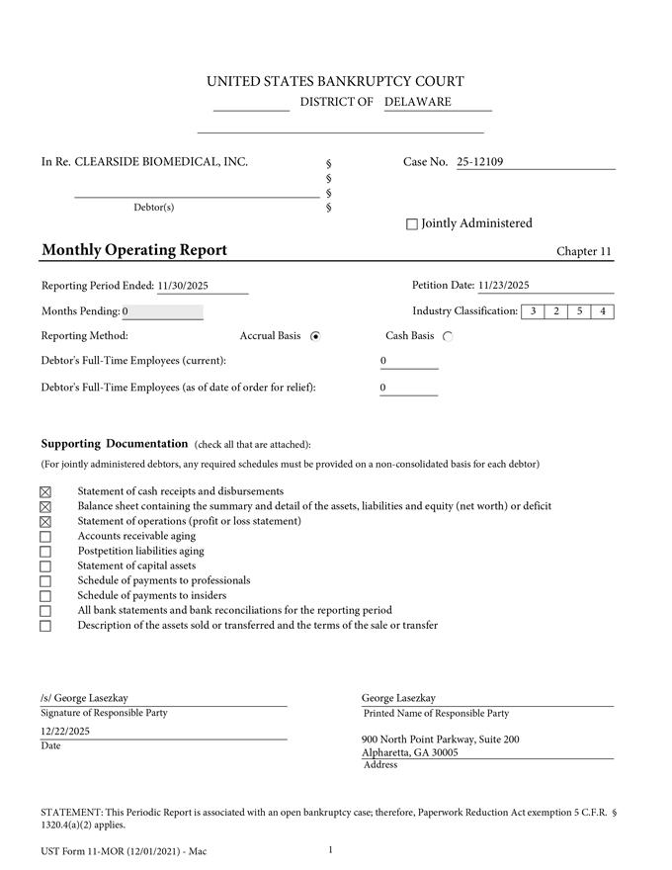

Case 25-12109-TMH Doc 115 Filed 12/23/25 Page 2 of 18
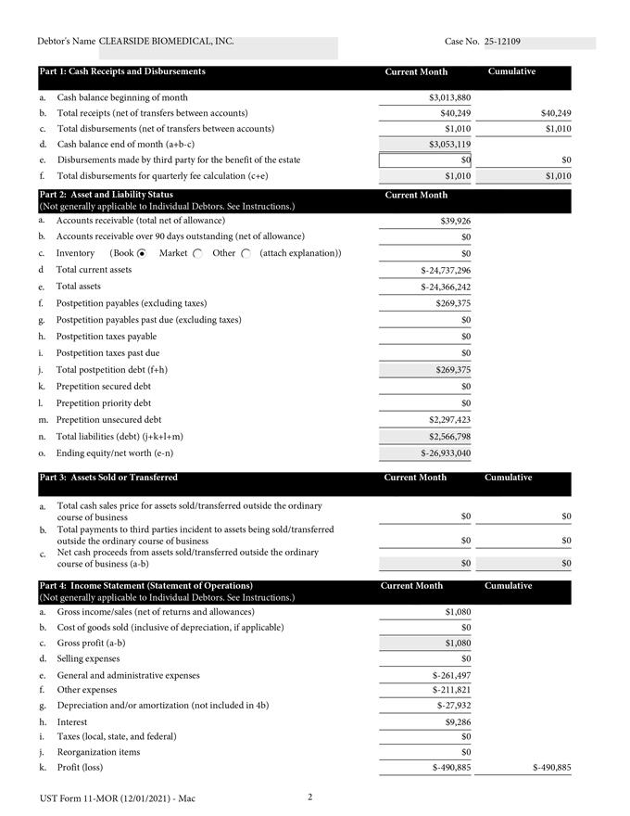

Case 25-12109-TMH Doc 115 Filed 12/23/25 Page 3 of 18
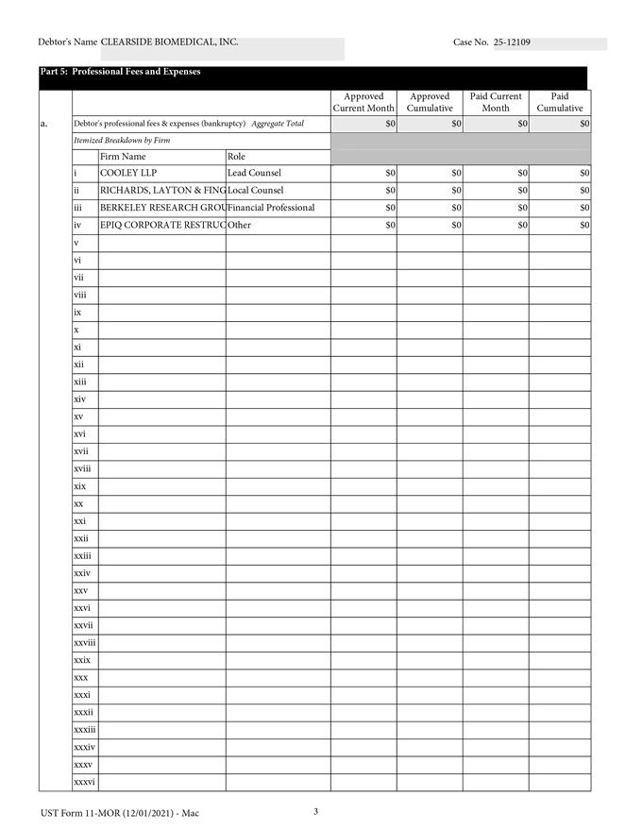

Case 25-12109-TMH Doc 115 Filed 12/23/25 Page 4 of 18
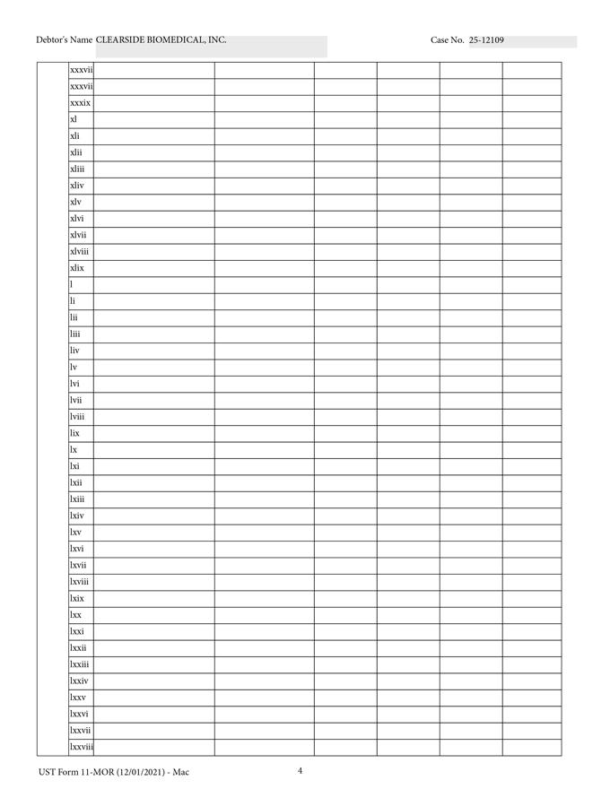

Case 25-12109-TMH Doc 115 Filed 12/23/25 Page 5 of 18
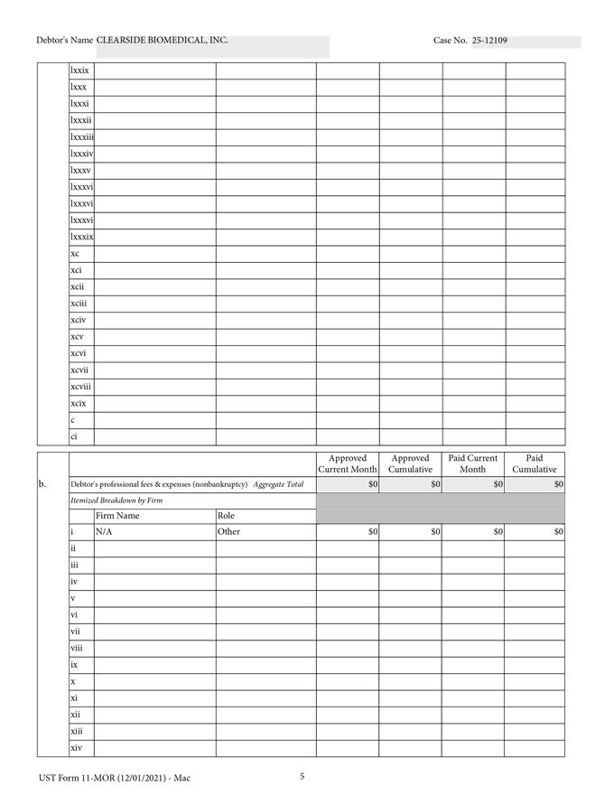

Case 25-12109-TMH Doc 115 Filed 12/23/25 Page 6 of 18
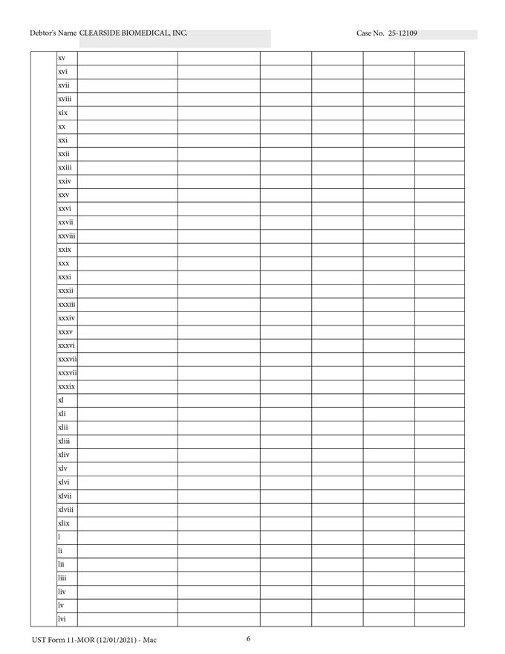

Case 25-12109-TMH Doc 115 Filed 12/23/25 Page 7 of 18
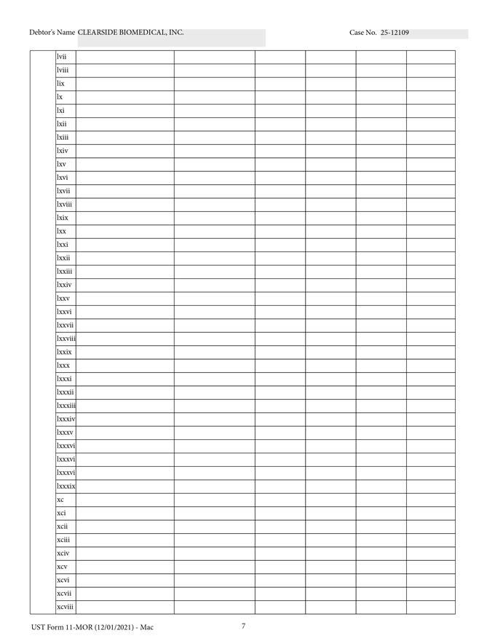

Case 25-12109-TMH Doc 115 Filed 12/23/25 Page 8 of 18
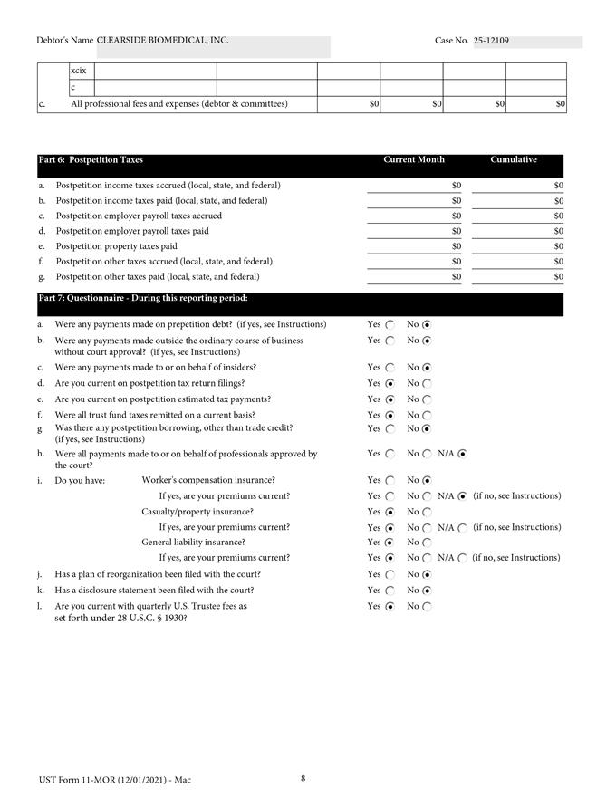

Case 25-12109-TMH Doc 115 Filed 12/23/25 Page 9 of 18
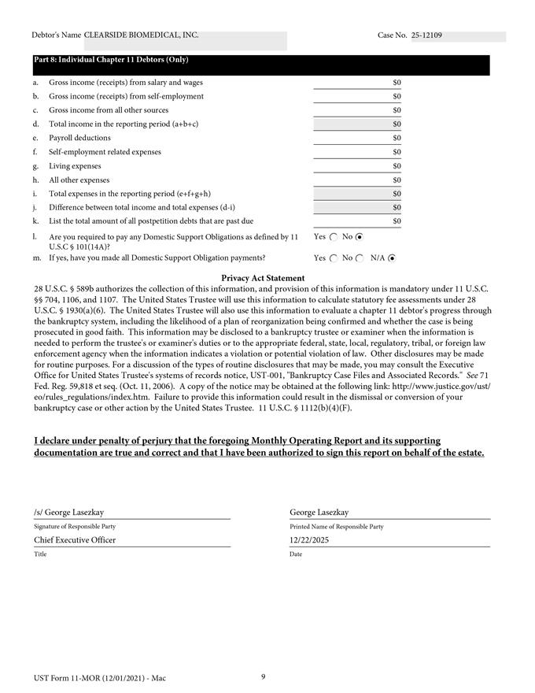

Case 25-12109-TMH Doc 115 Filed 12/23/25 Page 10 of 18
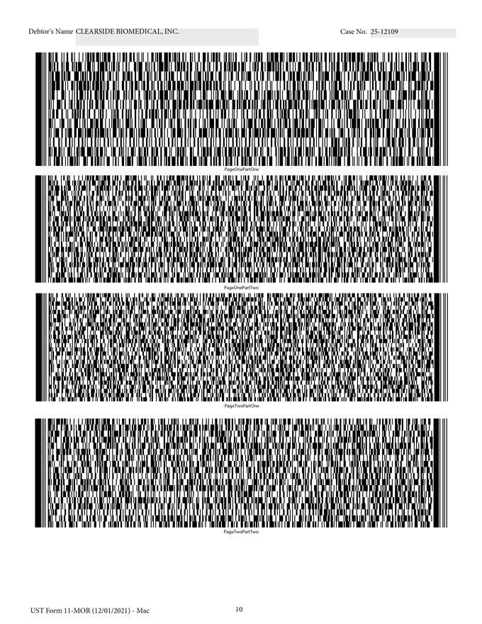

Case 25-12109-TMH Doc 115 Filed 12/23/25 Page 11 of 18
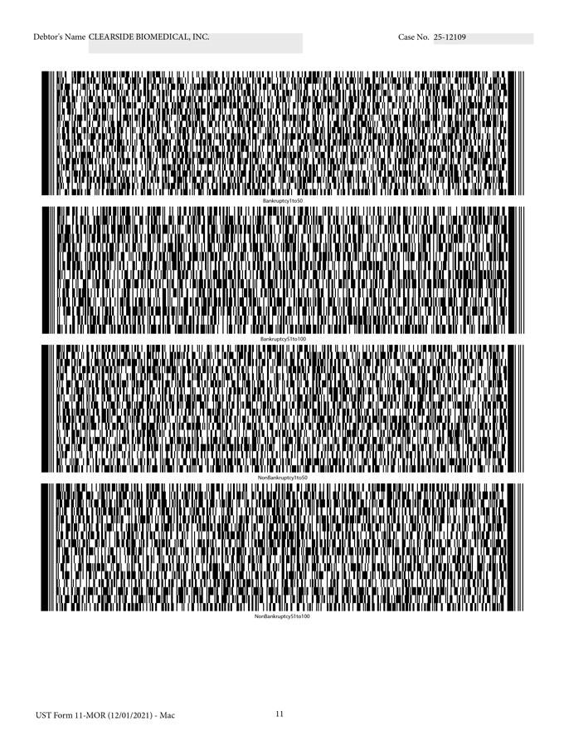

Case 25-12109-TMH Doc 115 Filed 12/23/25 Page 12 of 18
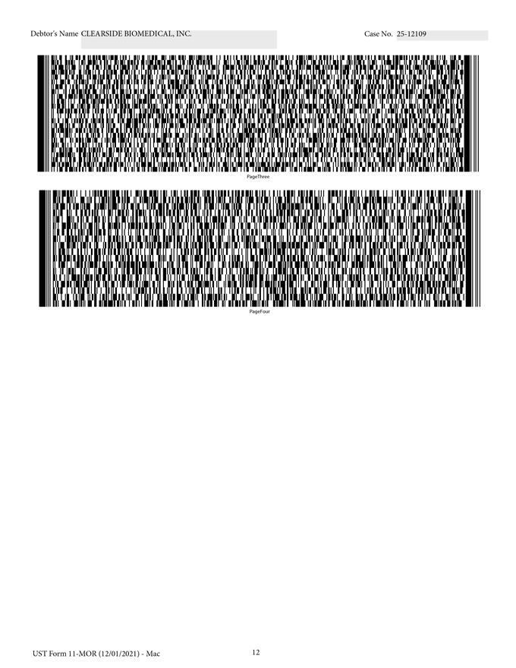

Case 25-12109-TMH Doc 115 Filed 12/23/25 Page 13 of 18

IN THE UNITED STATES BANKRUPTCY COURT

FOR THE DISTRICT OF DELAWARE


In re:
Chapter 11
CLEARSIDE BIOMEDICAL, INC.1
Case No. 25-12109 (TMH)

Debtor.

GLOBAL NOTES TO THE MONTHLY OPERATING

REPORT SUPPORTING DOCUMENTATION
Reporting Period: November 23, 2025 – November 30, 2025

The debtor and debtor in possession (the “Debtor”) in the above-captioned chapter 11 case (the “Chapter 11 Case”) has prepared and filed the attached November 30, 2025 Monthly Operating Report (the “MOR”) in the United States Bankruptcy Court for the District of Delaware (the “Court”). The Debtor has prepared the MOR with the assistance of its advisors and professionals solely for the purpose of complying with the reporting requirements applicable in the Chapter 11 Case and is in a format consistent with the instructions provided by the Office of the United States Trustee for the District of Delaware. The financial information contained herein is unaudited, limited in scope, and is not prepared in accordance with accounting principles generally accepted in the United States of America nor in accordance with federal or state securities laws or other applicable non-bankruptcy law or in lieu of complying with any periodic reporting requirements thereunder.

In preparing the MOR, the Debtor relied on financial data available from the limited books and records available to it at the time of such preparation, as well certain filings from the docket in the Chapter 11 Case. Although the Debtor made commercially reasonable efforts to ensure the accuracy and completeness of the MOR, inadvertent errors or omissions may exist.2 For the avoidance of doubt, the Debtor hereby reserves its right to amend and supplement the MOR as may be necessary or appropriate.

Each signatory to the MOR has necessarily relied upon the efforts, statements, advice, and representations of personnel of the Debtor and its advisors and professionals. Each signatory has not (and could not have) personally verified the accuracy of each statement, representation, and answer contained in the MOR.

- The Debtor and the last four digits of its taxpayer identification number are: Clearside Biomedical, Inc. (7375). The Debtor’s mailing address is 900 North Point Parkway, Suite 200, Alpharetta, GA 30005.

- The Debtor, and its agents, advisors, attorneys, and other professionals, as applicable, do not guarantee or warrant the accuracy or completeness of the data that is provided in the MOR.

Case 25-12109-TMH Doc 115 Filed 12/23/25 Page 14 of 18

Part 1: Cash Receipts and Disbursements. The MOR presents the Debtor’s receipts and disbursements for the period from November 23, 2025 through November 30, 2025.

Part 2: Asset and Liability Status. The amounts identified in Part 2 of the MOR are derived from the Debtor’s unaudited and estimated accrual-based Balance Sheet as of November 30, 2025. Intercompany balances represent the cumulative receivable / (payable) amounts between the Debtor and its non-Debtor subsidiary, which are fully offset on a consolidated basis. Accounts Payable and Accrued Liabilities have been split based on amounts owed for pre- and post- petition balances to the best of the Debtors’ ability, and are subject to an ongoing reconciliation process. Post-petition payables include accrued liability amounts.

Part 3: Assets Sold or Transferred. The Debtor did not sell any assets outside the ordinary course of business from November 23, 2025 to November 30, 2025.

Part 4: Income Statement (Statement of Operations). This MOR presents the Debtor’s best estimate of its accrual-basis Statement of Operations for the period from November 23, 2025 through November 30, 2025. General and Administrative expenses are inclusive of all Selling, General, and Administrative expenses. Other expenses are inclusive of research and development expenses as well as non-cash stock-based compensation expense.

Part 5: Professional Fees and Expenses. The Debtor did not make any payments to restructuring professionals (whether retained or anticipated to be retained) during the period from November 23, 2025 through November 30, 2025.

Part 6: Postpetition Taxes. The Debtor collects, withholds, and incurs income taxes, sales and use taxes, ad valorem property taxes, business entity taxes and fees, and licensing and regulatory fees (collectively, the “Taxes and Fees”). The Debtor remits the Taxes and Fees to various federal, state, and local governments (collectively the “Authorities”) on a periodic basis in accordance with applicable law. On December 19, 2025, the Court entered an order [Docket No. 96] authorizing, but not directing, the Debtor to, among other things, pay Taxes and Fees that arise or accrue in the ordinary course of business on a postpetition basis consistent with prepetition practices. The Debtor did not pay or accrue any postpetition taxes for the period from November 23, 2025 through November 30, 2025. The Debtor believes that it is current with respect to any outstanding, post-petition amounts due.

MOR Part 7: Questionnaire. The Debtor made no payments to insiders for the period from November 23, 2025 through November 30, 2025. For purposes of this MOR, the Debtor defined “insiders” pursuant to section 101(31) of the Bankruptcy Code as: (a) directors; (b) officers; (c) persons in control of the Debtor; (d) relatives of the Debtor’s directors, officers, or persons in control of the Debtor; and (e) Debtor and non-Debtor affiliates of the foregoing. Moreover, the Debtor does not take a position with respect to: (a) any insider’s influence over the control of the Debtor; (b) the management responsibilities or functions of any such insider; (c) the decision making or corporate authority of any such insider; or (d) whether the Debtor or any such insider could successfully argue that he or she is not an “insider” under applicable law, with respect to any theories of liability, or for any other purpose.

* * * END OF GLOBAL NOTES * * *

In re Clearside Biomedical, Inc. Case 25-12109-TMH |  | Doc 115 Filed 12/23/25 Page 15 of 18 | Case No. 2
Debtor |  |  | Reporting Period: 11/23/25 to 1
 | SCHEDULE OF CASH RECEIPTS AND DISBURSEMENTS
 | Line Item | Current Period
 | CASH BEGINNING OF MONTH | 3,013,880
 | RECEIPTS
 | Collections of Accounts Receivable | 30,963
 | Other Receipts | 9,286
 | TOTAL RECEIPTS | 40,249
 | DISBURSEMENTS
 | Independent Contractors | -
 | Vendor Payables | -
 | Rent & Occupancy | -
 | Taxes | -
 | Other Operating Disbursements | (697)
 | Other Non-Operating Disbursements | (313)
 | TOTAL DISBURSEMENTS | (1,010)
 | NET CASH FLOW
 | (RECEIPTS LESS DISBURSEMENTS) | 39,239
 | CASH - END OF MONTH | 3,053,119
In re Clearside Biomedical, Inc. Case 25-12109-TMH Doc 115 Filed 12/23/25 |  | Page 16 of 18 | Case No. 2
Debtor |  |  | Reporting Period: 11/23/25 to 1
 | BALANCE SHEET (UNAUDITED)
 | Line Item | Current Period
 | ASSETS
 | Cash | 3,053,119
 | Accounts Receivable | 39,926
 | Prepaid Expenses | 2,211,180
 | Intercompany Receivables (Payables) | (30,041,522)
 | TOTAL CURRENT ASSETS | (24,737,296)
 | Property and Equipment, Net | 15,661
 | Right of Use Asset | 324,955
 | Other Assets | 30,437
 | TOTAL ASSETS | (24,366,242)
 | LIABILITIES AND EQUITY
 | A/P (Pre-Petition) | 47,893
 | A/P | -
 | Accrued Liabilities (Pre-Petition) | 271,278
 | Accrued Liabilities | 269,375
 | Current Portion of Lease Liability | 385,808
 | TOTAL CURRENT LIABILITIES | 974,354
 | Warrant Liabilities | 1,192,444
 | Other Non-Current Liabilities | 400,000
 | TOTAL LIABILITIES | 2,566,798
 | Common Stock | 78,510
 | Additional Paid-In-Capital | 320,373,858
 | Accumulated Deficit | (347,385,409)
 | TOTAL EQUITY | (26,933,040)
 | TOTAL LIABILITIES & EQUITY | (24,366,242)
In re Clearside Biomedical, Inc. Case 25-12109-TMH Doc 115 Filed 12/23/25 |  | Page 17 of 18 |  | Case No. 2
Debtor |  |  | Reporting Period: 11/23/25 to 1
 | STATEMENT OF OPERATIONS (UNAUDITED)
 | Line Item | Current Period
 | REVENUES
 | License and Other Revenue | 1,080
 | TOTAL REVENUES | 1,080
 | EXPENSES
 | Cost of Goods Sold |  | -
 | Research and Development | (6,868)
 | General and Administrative | (261,497)
 | Stock Based Compensation | (204,953)
 | Depreciation | (27,933)
 | TOTAL EXPENSES | (501,251)
 | INCOME (LOSS) BEFORE OTHER INCOME (LOSS) | (500,171)
 | OTHER INCOME (LOSS)
 | Interest Income | 9,286
 | Other Income, Net |  | -
 | TOTAL OTHER INCOME (LOSS) | 9,286
 | NET INCOME (LOSS) | (490,885)
In re Clearside Biomedical, Inc. | Case 25-12109-TMH Doc 115 | Filed 12/23/25 Page 18 of 18 |  | Case No. 2
Debtor |  |  | Reporting Period: 11/23/25 to 1
 | BANK ACCOUNTS
 |  | Account number | Period-end bank
Bank name | Account type | (last four digits) | balance | Currency
Silicon Valley Bank | Clearside Operating Account | 1971 | 250,000 | USD
Silicon Valley Bank | Cash Sweep Account | 9063 | 1,194,380 | USD
Morgan Stanley | Money Market Investment Account | 3453 | 1,608,740 | USD
TOTAL BANK BALANCE |  |  | 3,053,119 | USD

